**Report on Data Collection for Revenue Analysis**

This report focuses on revenue data collected from NSE-listed multinational corporations (MNCs) in India, sourced from Moneycontrol.com, with additional company details obtained from Cleartax.in. The objective is to analyse revenue trends, identify significant changes, and assess the profitability. Analysing revenue data from NSE-listed multinational corporations (MNCs) in India offers valuable insights into the economic landscape and business performance in the country. These companies, operating across diverse industries, represent a significant segment of the Indian market and are subject to stringent regulatory requirements, ensuring transparency and reliability in financial reporting.

It is important to note that the data collected for this analysis pertains to the period after the onset of the COVID-19 pandemic, highlighting the resilience and adaptability of these companies in response to unprecedented economic disruptions. By examining revenue trends and profitability post-COVID-19, this analysis provides a comprehensive understanding of how Indian MNCs have navigated the challenges posed by the pandemic and continued their growth trajectory.

**Data Collection Methodology:**

* **Source of Data:** Revenue data for the fiscal years 2021, 2022, and 2023 were collected from Moneycontrol.com, a reputable financial data platform known for its comprehensive coverage of stock market information. Company addresses and email addresses were sourced from Cleartax.in, ensuring consistency and reliability in data collection.
* **Post-Pandemic Context:** The data collected pertains to the period after the onset of the COVID-19 pandemic, providing insights into how MNCs in India have fared in the challenging economic environment brought about by the crisis.
* **Consistency:** The data collection process focused on ensuring consistency by relying on a single reputable source for revenue data (Moneycontrol.com). This approach minimizes discrepancies and enhances the reliability of the analysis.

**Graphical Representation:**

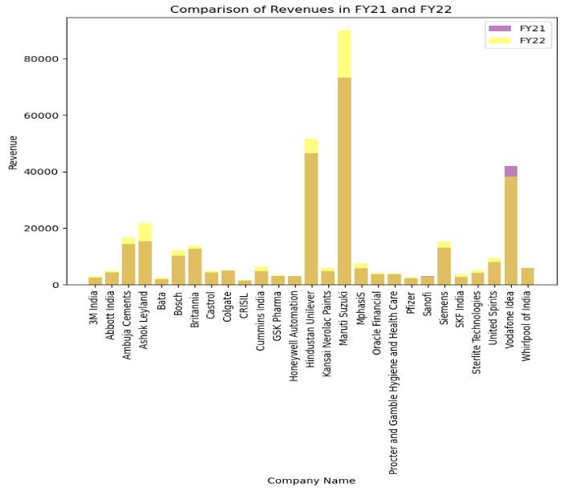 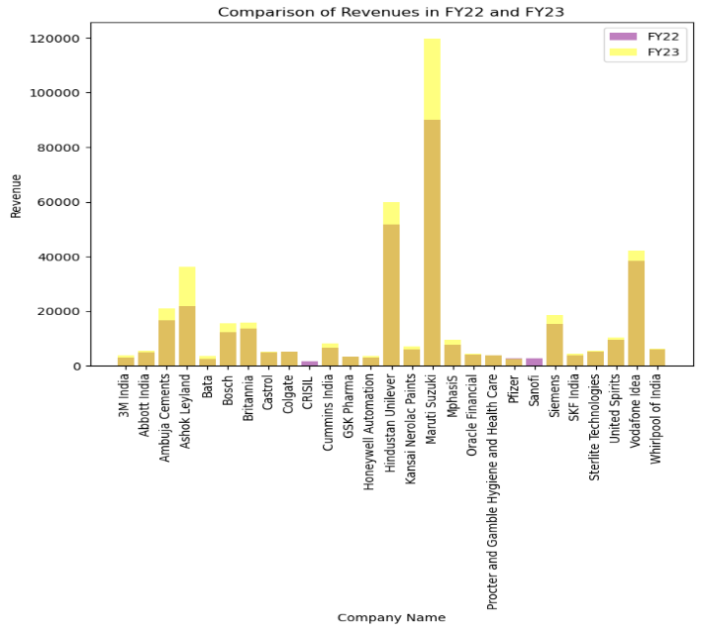

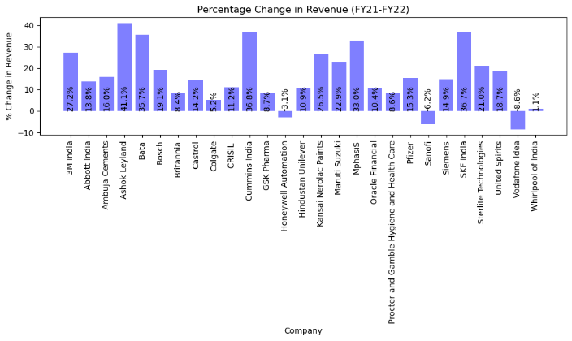 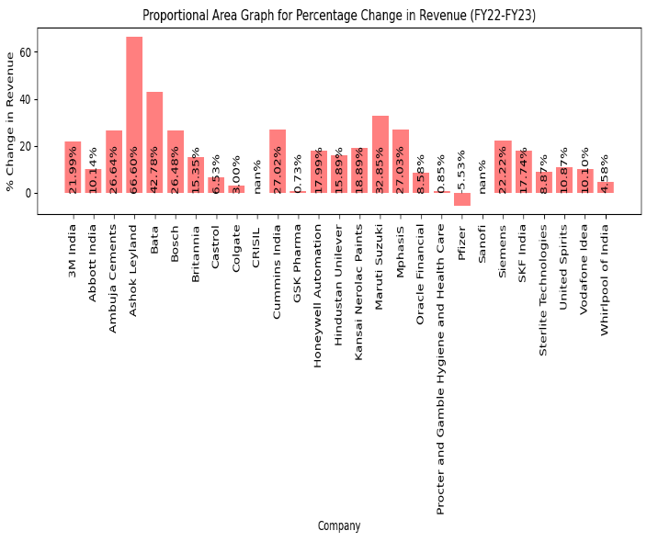

**Key Findings:**

* **Revenue Trends:** Analysis of the collected data reveals notable growth trends among NSE-listed MNCs post-pandemic. Companies such as Maruti Suzuki, Hindustan Unilever, and Ashok Leyland have demonstrated substantial increases in revenue over the analysed period.
* **Adaptability of NSE-listed MNCs:** As shown in the graph, almost all analysed companies exhibit profitability, with consistent revenue growth observed across multiple fiscal years. This underscores the resilience and adaptability of NSE-listed MNCs in India.
* **Profitability Assessment:** The profitability of each company was assessed based on their revenue performance. The majority of the analysed companies were deemed profitable, with consistent revenue growth observed across multiple fiscal years.
* **Companies with Significant Changes:** Several companies stand out for experiencing significant percentage changes in revenue. Notable examples include Maruti Suzuki, which recorded a 33% increase in revenue from FY22 to FY23, and Cummins India, with a remarkable 27% growth during the same period. While Ashok Leyland increased 41% and 67% in FY21 to FY22 and FY22 to FY23 respectively.

**Conclusion:**

The analysis underscores the resilience and dependability of NSE-listed multinational corporations (MNCs) in India, as evidenced by their consistent profitability. The majority of these companies have demonstrated sustained revenue growth, reflecting their ability to adapt to changing market conditions and capitalize on emerging opportunities. Their profitability can be attributed to several factors, including robust business strategies, diversified revenue streams, and effective risk management practices.

Moreover, the reliability of the findings is strengthened by the use of consistent and similar data sources, which ensures comparability and enhances the credibility of the analysis.

Moving forward, maintaining a systematic approach to data collection and analysis will be crucial for gaining actionable insights and making informed decisions in the dynamic business environment. By leveraging the insights gleaned from this analysis, stakeholders can gain a deeper understanding of market trends, identify growth prospects, and drive sustainable business growth.